1000L and 2000L Pump Well
INSTALLATION GUIDE
11 Cessna Way, Cambridge Tas 7170
PO Box 147, Sorell Tas 7172
0361283633 - 0408119442

- Pump Well Installation Instructions

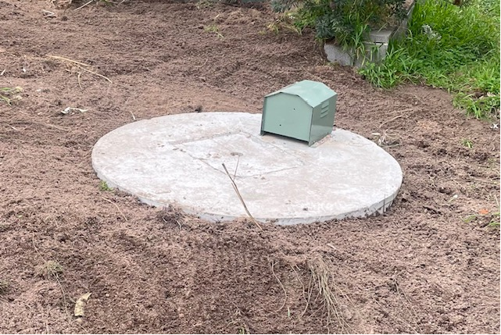

- The Pump Well is to be installed, by a licensed plumber, as per these instructions and local authority requirements. Any electrical connections are to be completed by a licensed electrician.

- The Pump Well can be supplied as an empty chamber in either 1000L or 2000L capacity or complete with pump, controller and alarm.

- Pumps, other pipe and electrical requirements are to be supplied and carried out by the relevant licensed tradesperson. The Pump Well is approved to the requirements of the Australian Standard AS/NZS1546.1:2008 On-site domestic wastewater treatment units – Septic tanks.

- Excavations

- Excavate site for installing tank in ground as per building code and local authority requirements. Ensure adequate pipe fall to inlet of the Pump Well.

a. Additionally, Pump Wells are to be sited:
i. Away from building foundations,
ii. Away from traffic areas, both vehicular and pedestrian,
iii. Away from or fenced off from animal stock pastures and areas.

- Refer to the tank dimensions diagram for correct levels.

- The 1000L Pump Well requires an excavation approximately 1040 mm deep and 1600mm in diameter (the exact depth will vary due to land fall and depth of bedding sand used).

- The 2000L Pump Well requires an excavation approximately 1800 mm deep and 1600mm in diameter (the exact depth will vary due to land fall and depth of bedding sand used)

Approx 1040mm (1000L)
Approx 1800mm (2000L)

Approx 1600mm

- Do not bury tank lid. Manhole cover must be finished at normal ground level to allow ongoing Pump Well inspection and maintenance.

- In the base of the excavation prepare a level 50mm bed of compacted sand or 7mm gravel and level.

5. Carefully lower tank base into excavation - do not drop.

- CONNECTION

- Connection to the Pump Well is via 100mm PVC DWV Sewer pipe through the side wall connection.
- Ensure the pipe seal is clean and correctly seated. Use a standard jointing lubricant. Apply lubricant to spigot of pipe and ease the pipe through the seal until the pipe protrudes inside the Pump Well at least 150mm.
- Remove the Manhole Cover to install the pump. Carefully lower and position the pump in Pump Well.
- Connect any relevant pipe work and electrical cable through the top of the pump well. Any electrical installation and connections must be done by a licensed electrician.
- Seal any connection ports made in the top of the Pump Well with silicone.
- Set the floats for the pump level controls. The float should be set so the pump switches on when the level of fluid inside the Pump Well is below the invert level of the inlet. The pump should switch off to ensure the pump remains primed and no lower than the base flange of the Pump Well.
- Check correct operation of pump and floats.

- TANK ANCHORING

- The weight of the Pump Well is sufficient not requiring any specific anchoring.
- In areas of high-water table where tank floatation is possible it is recommended the lower ¼ of the Pump Well be encased with 25MPA concrete to the hole edge wall.

5. COMPLETION

- Fit Manhole Cover. Manhole cover should always be fitted to prevent unauthorised entry.
- Back fill around the Pump Well with clean fill. Only use clean fill and ensure full compaction in layers of the clean fill until the top. Do not use excavation waste, rubble rocks or large objects.
- The Pump Well must not be buried when finished. The Manhole Cover must be at ground level to ensure access for maintenance. The Pump Well can be covered with light mulch or garden bark only. Ensure all surface water run-off is directed away from pipe trenches septic tanks and the Pump Well.

1000 Litre Pump Well Specifications

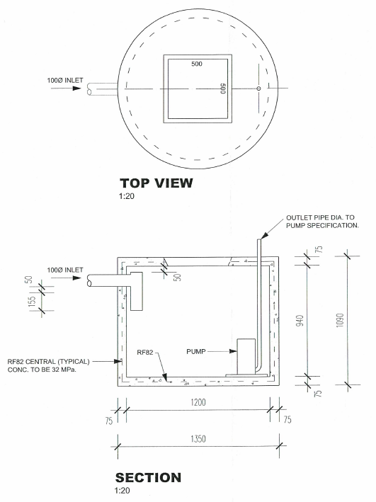

2000 Litre Pump Well Specifications

